Project 0 Design Document

Zhiyuan Zhang z667zhan

**1. Overview of classes**

Two classes are implemented in this design, one for the playlist and the other for the entries in the list (songs). Class ‘Song’ stores the title and artist of a song, with functions provided to set and get these data. Class ‘Playlist’ is an array of ‘Song’, with functions to add, delete, and “play” songs at certain position.

**2. UML class diagram**

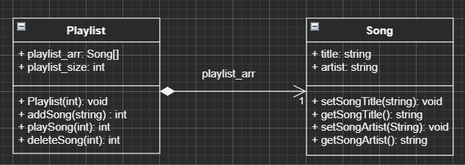

**3. Design decisions:**

For Playlist class:

An integer is needed to construct the playlist array with a specified size; in the destructor the array also needs to be deleted. Besides, since the size of a playlist cannot change once the playlist is initialized, “const” is used on playlist_size.

For Song class:

It has two strings, and the methods are used to set and get these parameters only.

**4. Test strategy:**

For adding songs, it should not add a song if:

The array is full;

The song is already in the list (the title and artist are identical).

For playing song at position n, it should not play a song if position n is empty or n > playlist size.

For deleting song at position n, it should not delete a song if position n is empty or n> playlist size.

**5. Performance analysis:**

addSong(title, artist): O(n) since it checks every other song to make sure there is no duplication.

playSong(n): O(1) since it can access the target in an array in O(1) time with index

deleteSong(n): O(n) since it needs to move every song below position n up.